Using cisco packet tracer to simulate connecting computers in a company’s network and pinging each other as well as subnetting them to prevent access from unwanted party.

Cisco Packet Tracer is a computer networking simulation software.

After downloading and registering the packet tracer app, on the home page select a switch at the bottom left and select the number of computers to connect to it.

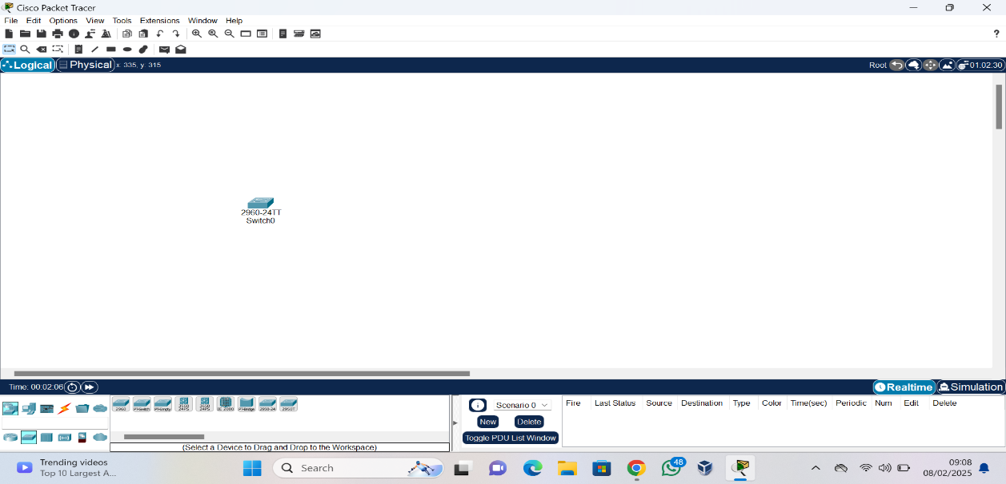

All the computers are renamed so 3 computers belong to each department in the company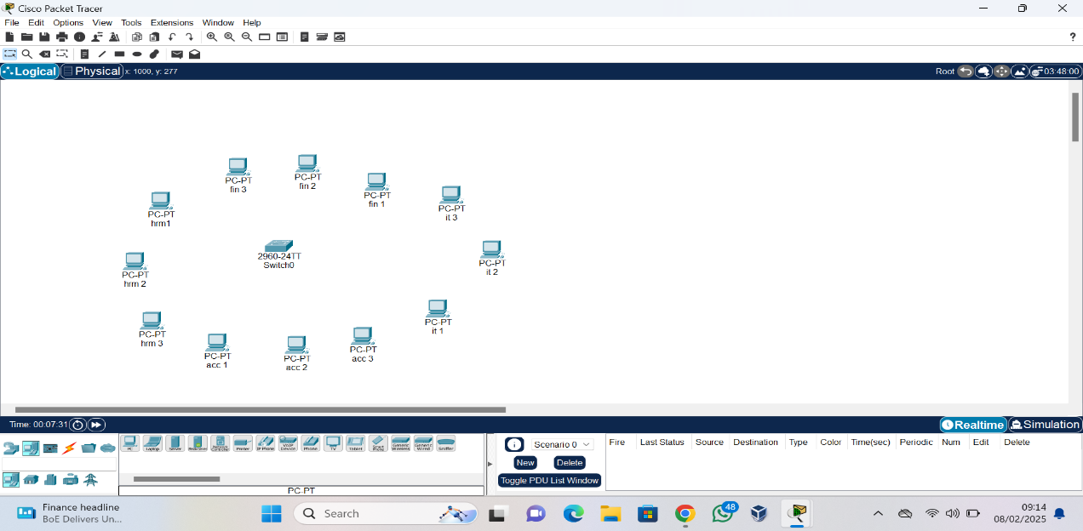

The computers are then connected to the switch using the cables

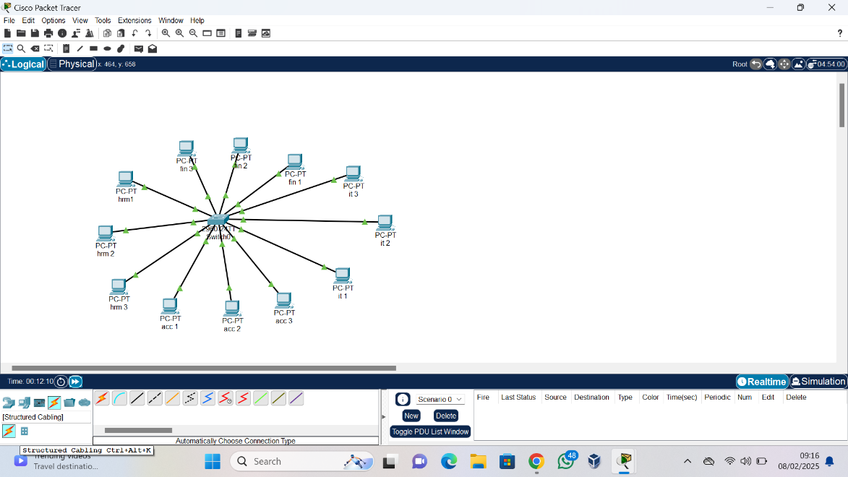

But they are yet to have an IP address which can be assigned to them by clicking on the computer, selecting the desktop option and clicking IP configuration. 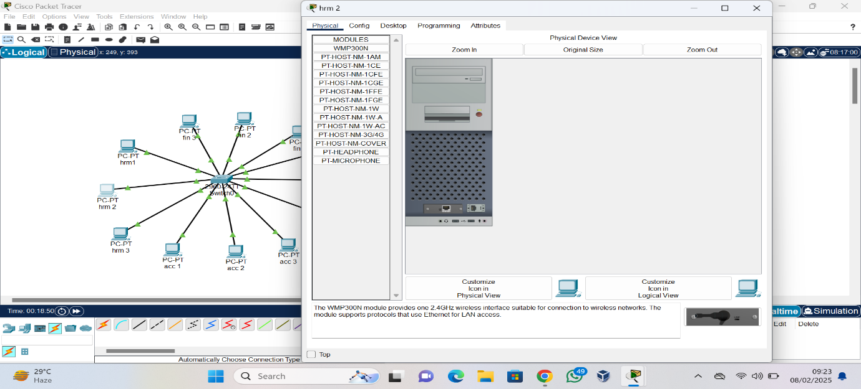

An IP address can then be manually assigned to each computer

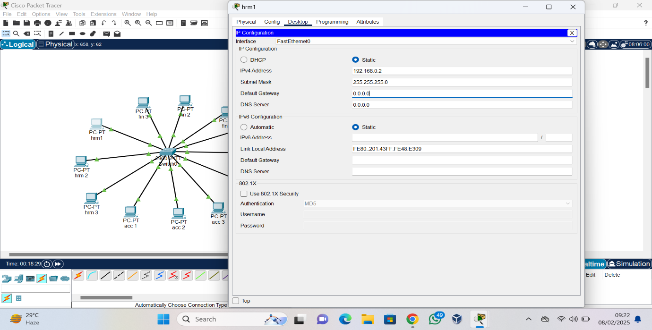

Afterwards click on the computer and go to command prompt, in the command prompt run “ipconfig” to check for the computer information such as the assigned IP address

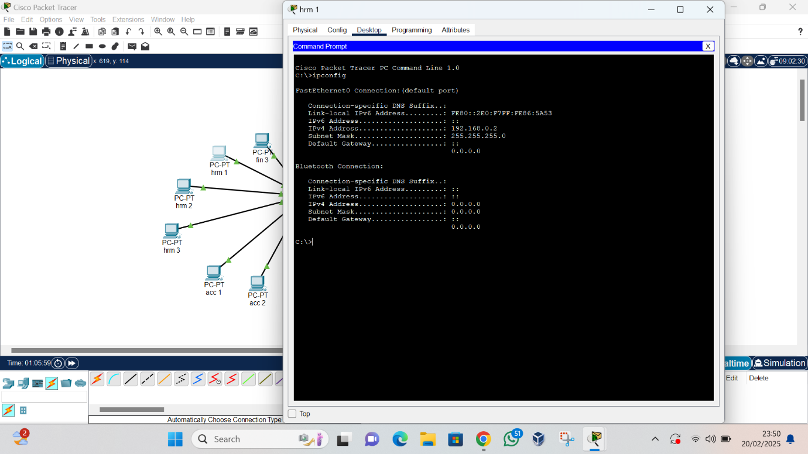

Any computer on the network are able to ping each other and interact with one another with no data loss

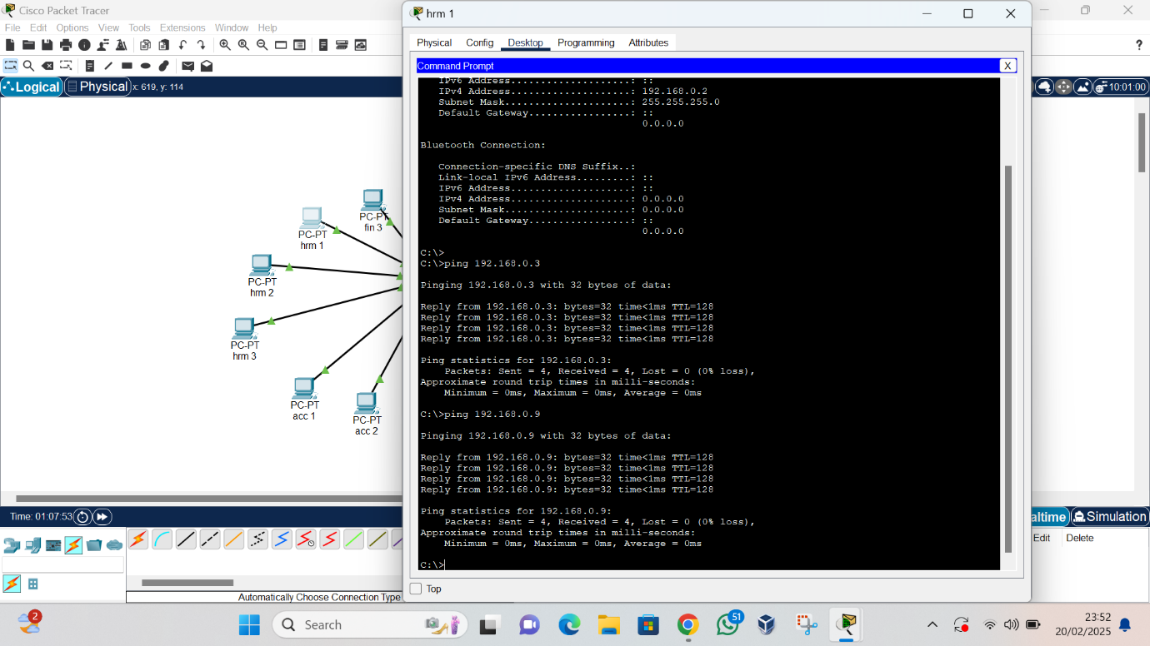

However, to segment a network so different departments in a company have different type of access to keep some information confidential.

This can be done using a Virtual Local Area Network (VLAN)

The previous connection has to be deleted, and more switches added so computers in each department are only connected to their own switch

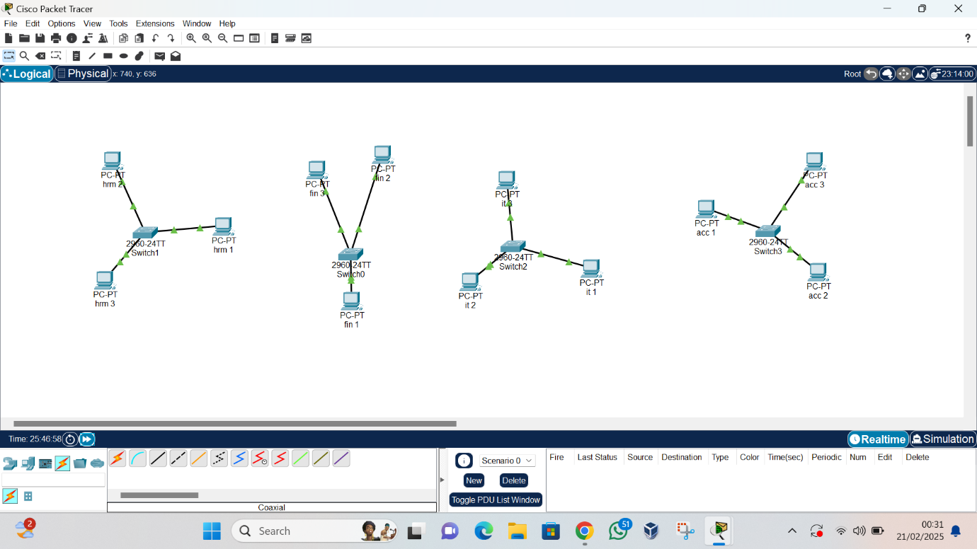

The computers are then placed in VLAN 1,2,3 and 4 respectively. The devices are configuring into different subnets. This is done by assigning a gateway for the switch e.g 192.168.20.1

Then an IP address in the subnet is assigned to the devices hosted on this network e.g 192.168.20.2, 192.168.20.3 and so on

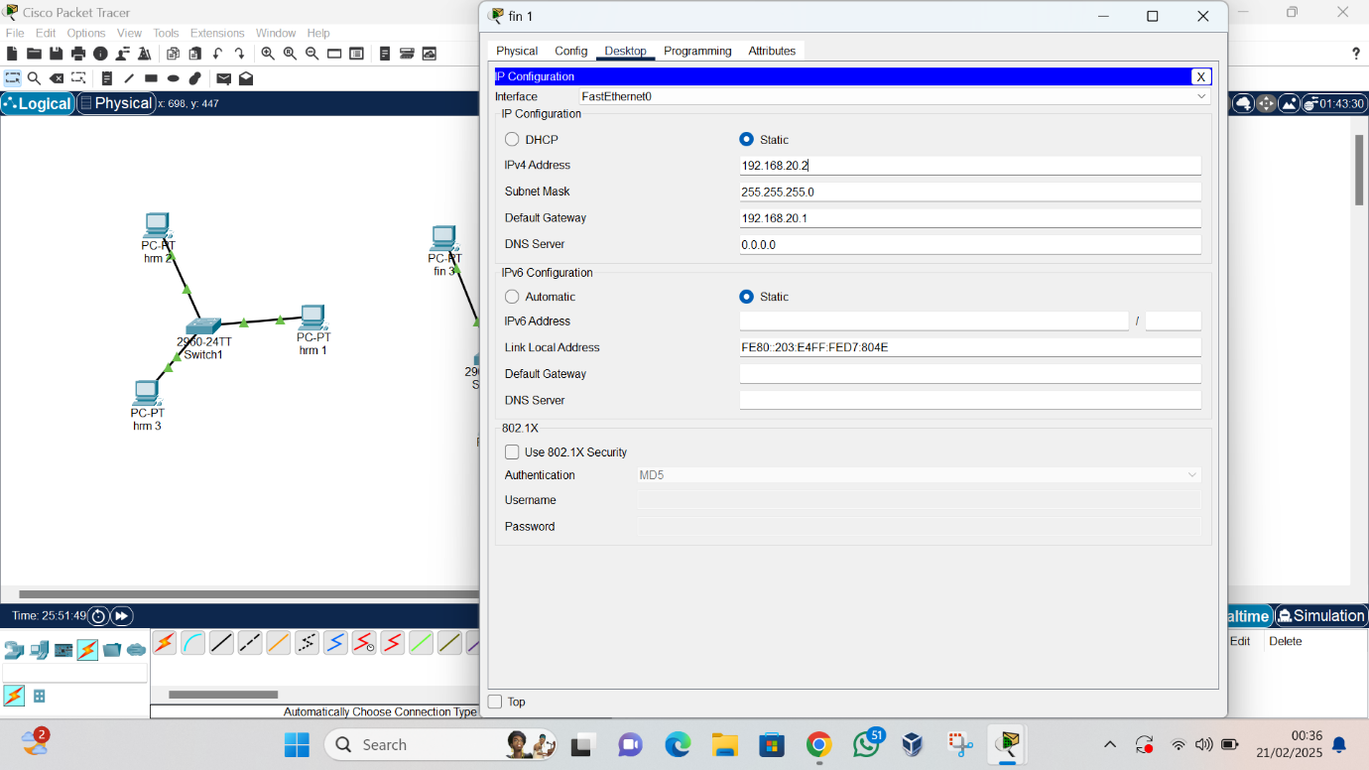

Similar thing is done for the computers in other department but on .30, .40 and .50 respectively.

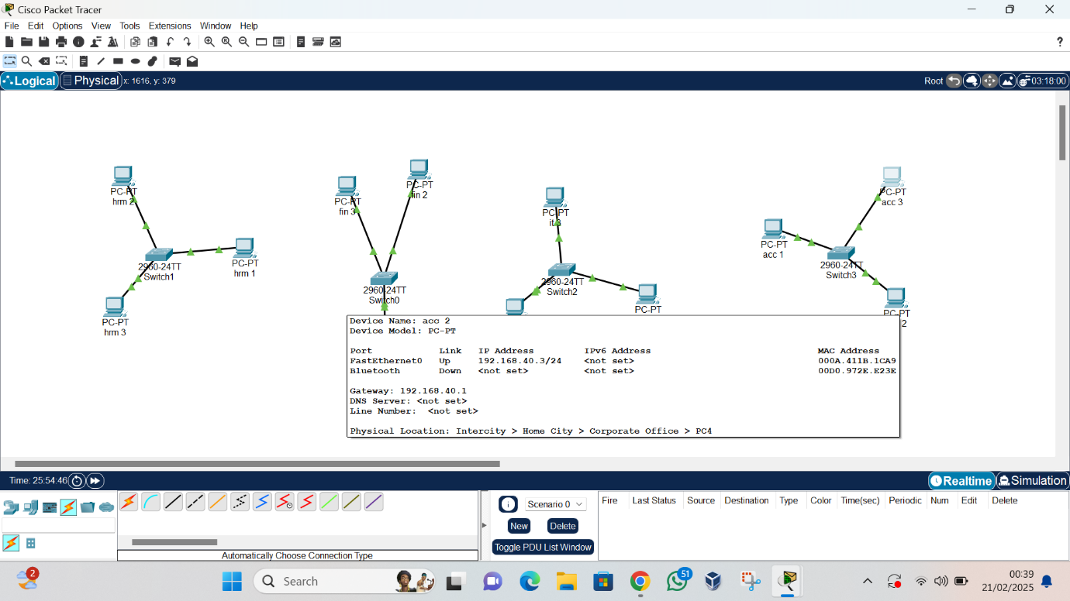

Now only computer on the same subnetwork can interact with each other

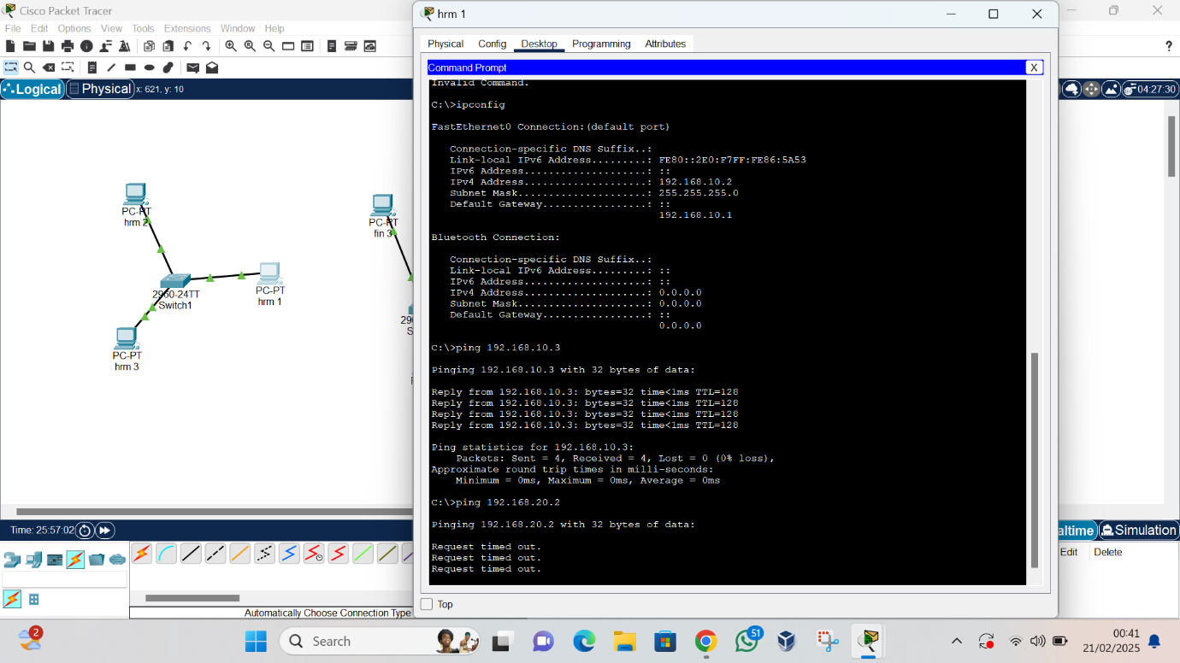

And computers on different subnetwork are unable to interact with each other.

